**COMSAT UNIVERSITY ISLAMABAD ATTOCK CAMPUS**



**INFORMATION SECURITY**

**NAME:** MENAHIL NOOR

**REGISTRATION NO:** SP24-BSE-035

**ASSIGNMENT:** 01

**SUBMITTED TO:** MA’AM AMBREEN

**DATE:** 08-SEPTEMBER-2025

**Task 1**:

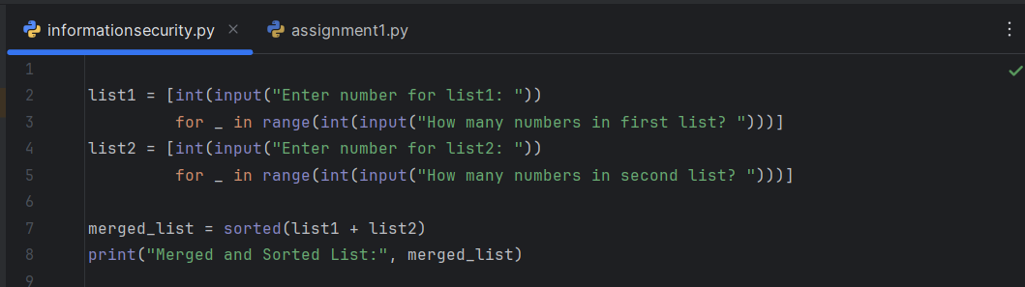Create two lists based on the user values. Merge both the lists and display in sorted order.

**OUTPUT:**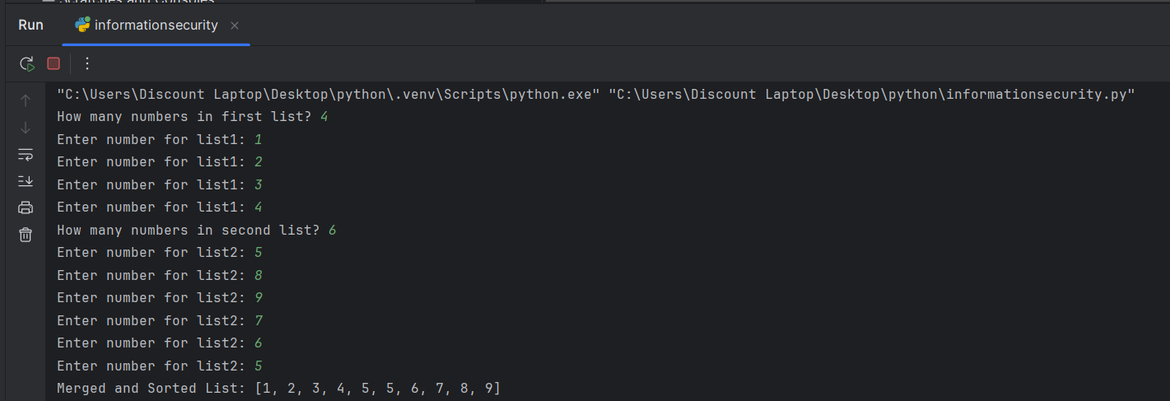

**Task 2**:

Repeat the above activity to find the smallest and largest element of the list. (Suppose all the elements are integer values)

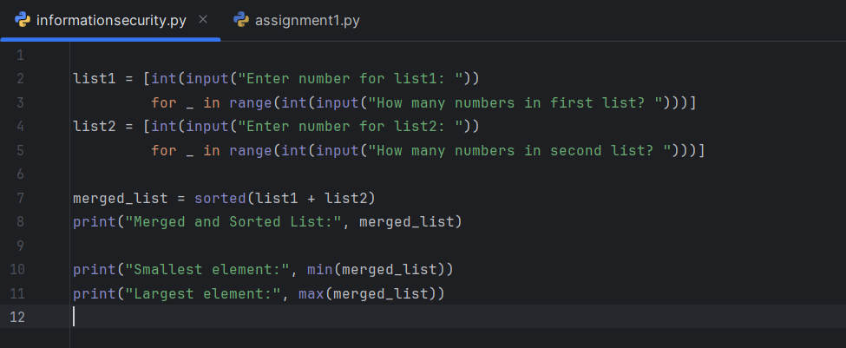

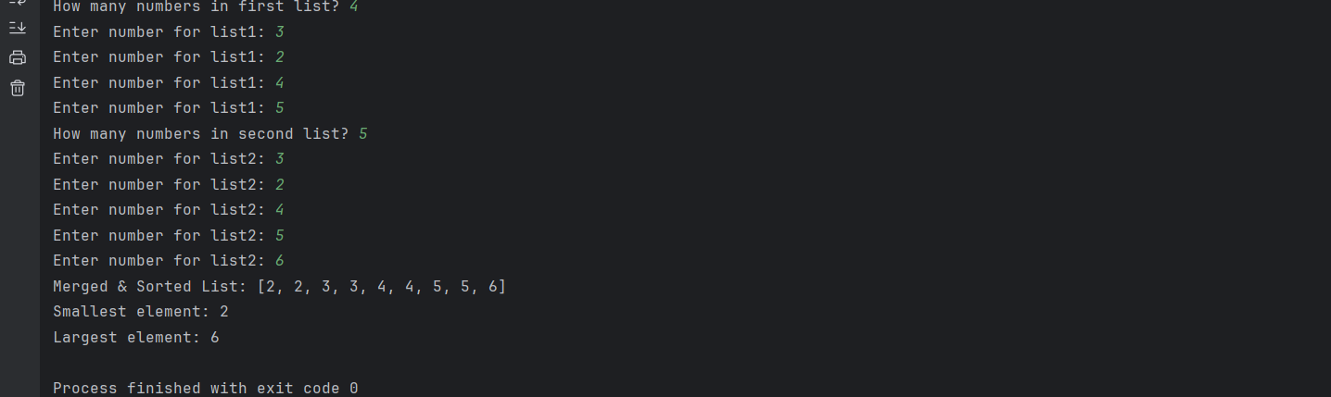**OUTPUT:**

**Task 3:**

For this exercise, you will keep track of when our friend’s birthdays are, and be able to find that information based on their name. Create a dictionary (in your file) of names and

birthdays. When you run your program it should ask the user to enter a name, and return the

birthday of that person back to them. The interaction should look something like this:[3] **>>> Welcome to the birthday dictionary. We know the birthdays of:**

**Albert Einstein**

**Benjamin**

**FranklinAda**

**Lovelace**

**>>> Who's birthday do you want to**

**look up? Benjamin Franklin**

**>>> Benjamin Franklin's birthday is 01/17/1706.**

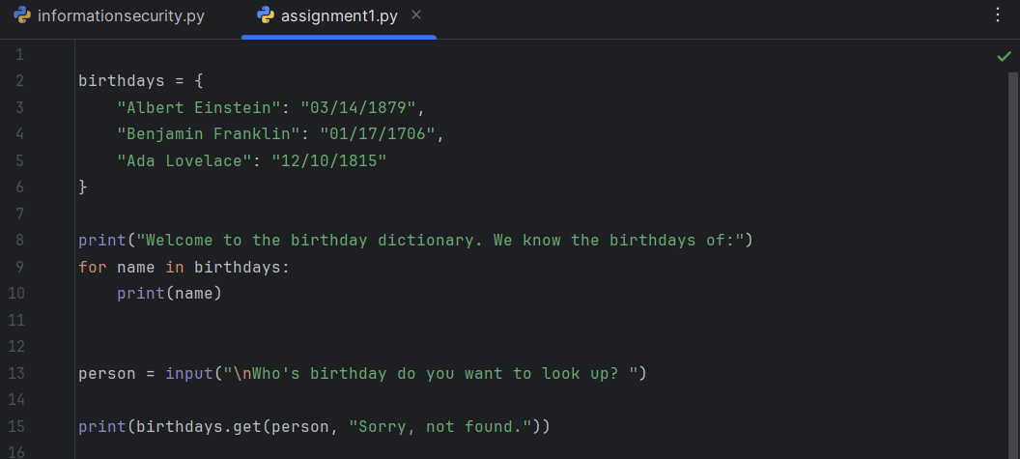

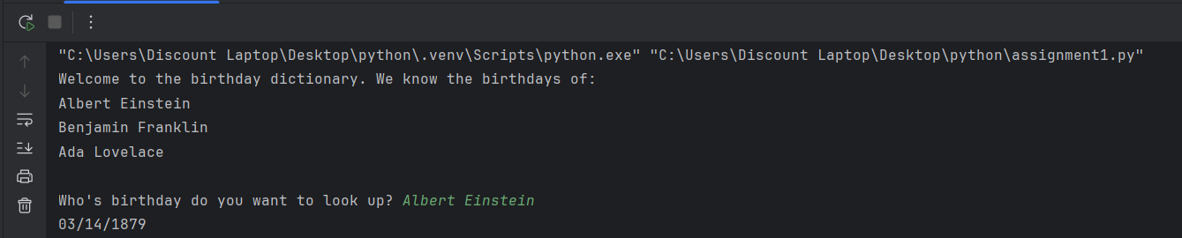**OUTPUT:**

**Task 4:**

Create a dictionary by extracting the keys from a given dictionary Write a program to create a new dictionary by extracting the mentioned keys from the below dictionary.

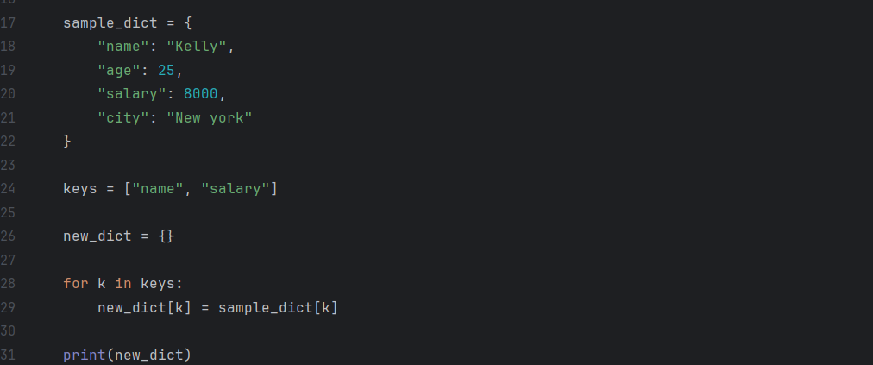

**OUTPUT:**

